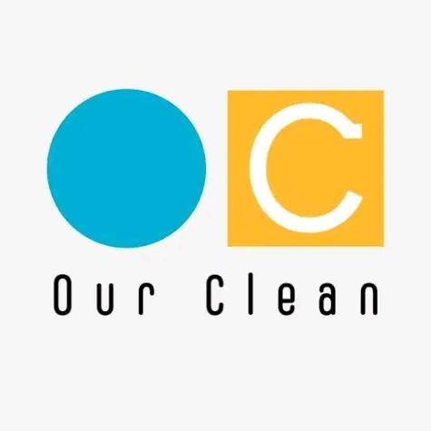

OUR CLEAN UK
OUR GROUP UK

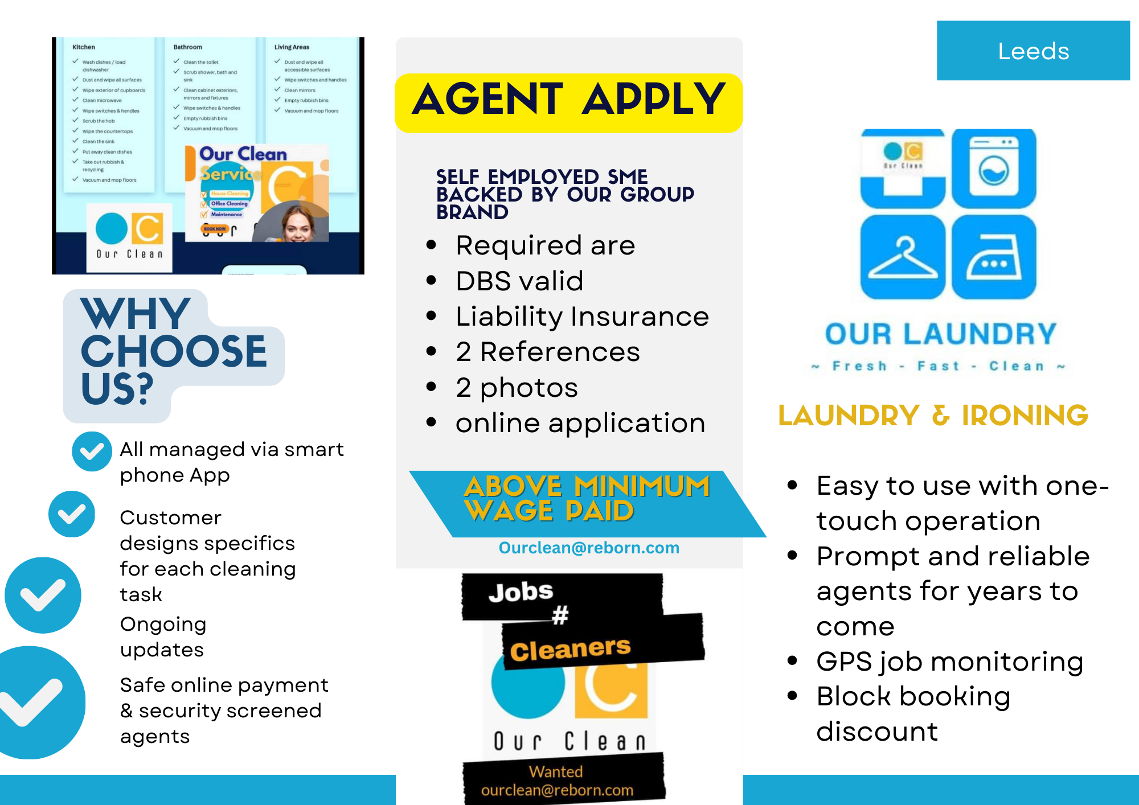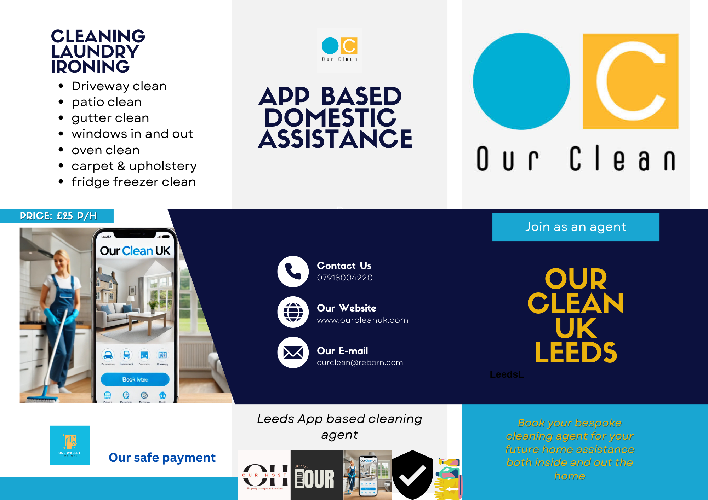

Value proposition

**Our Clean** empowers aspiring entrepreneurs to establish their own cleaning services without upfront costs. In an industry filled with diverse cleaning agents, each offering unique methods and pricing structures, the end results often vary in quality.
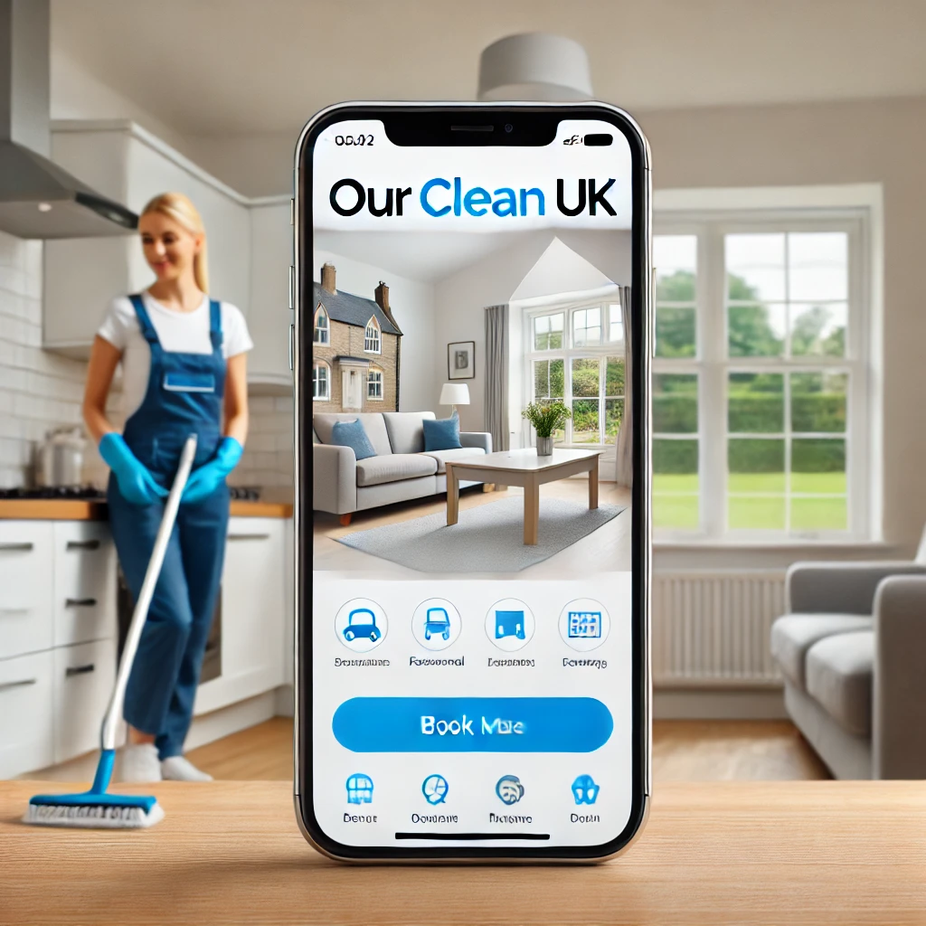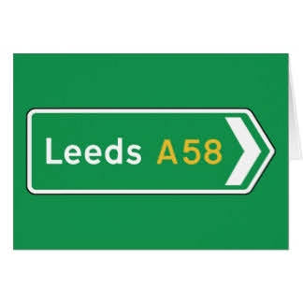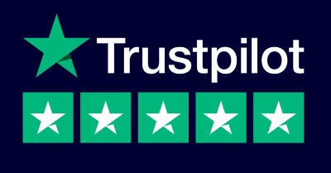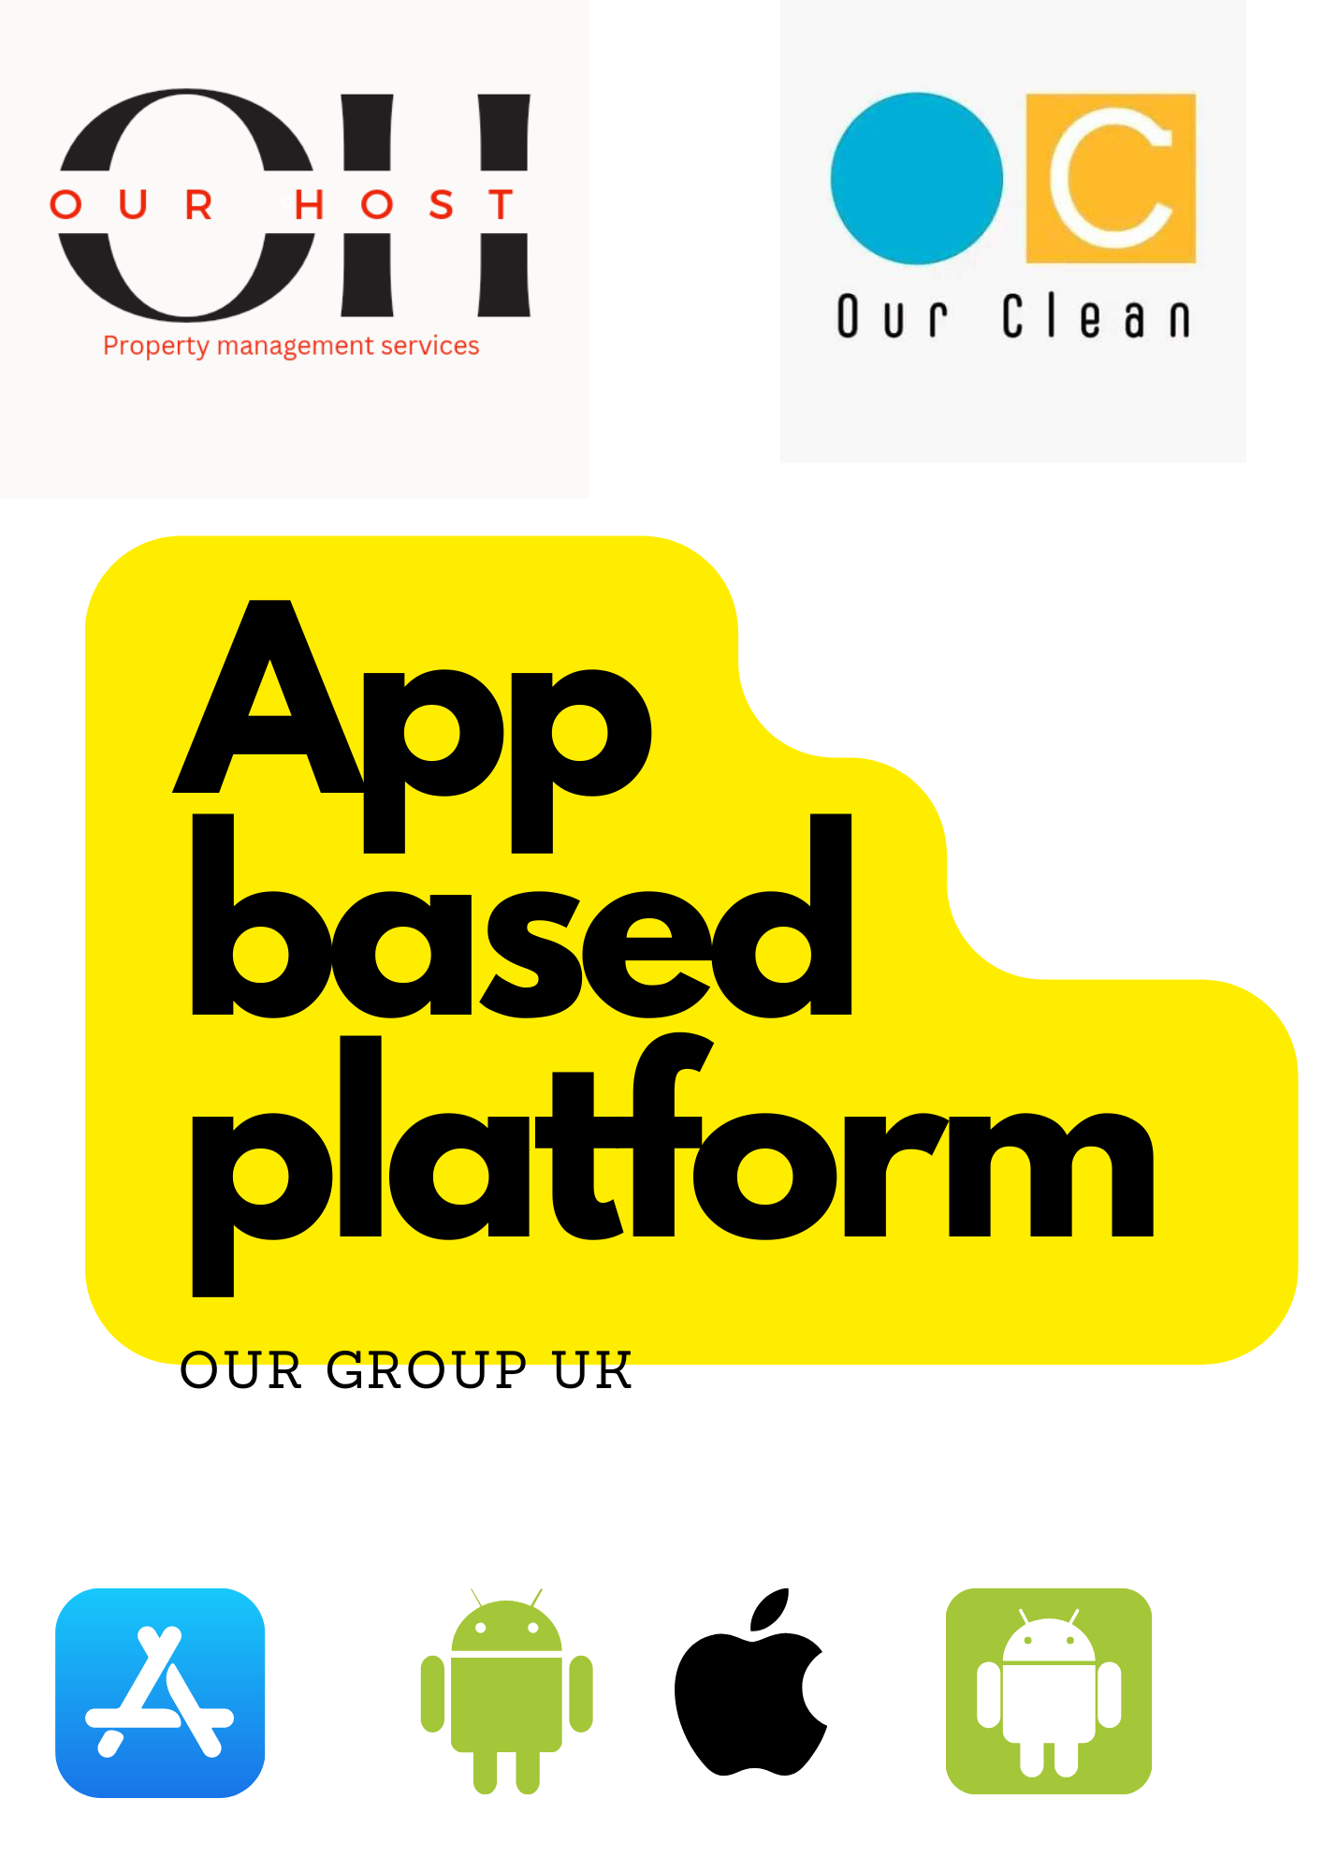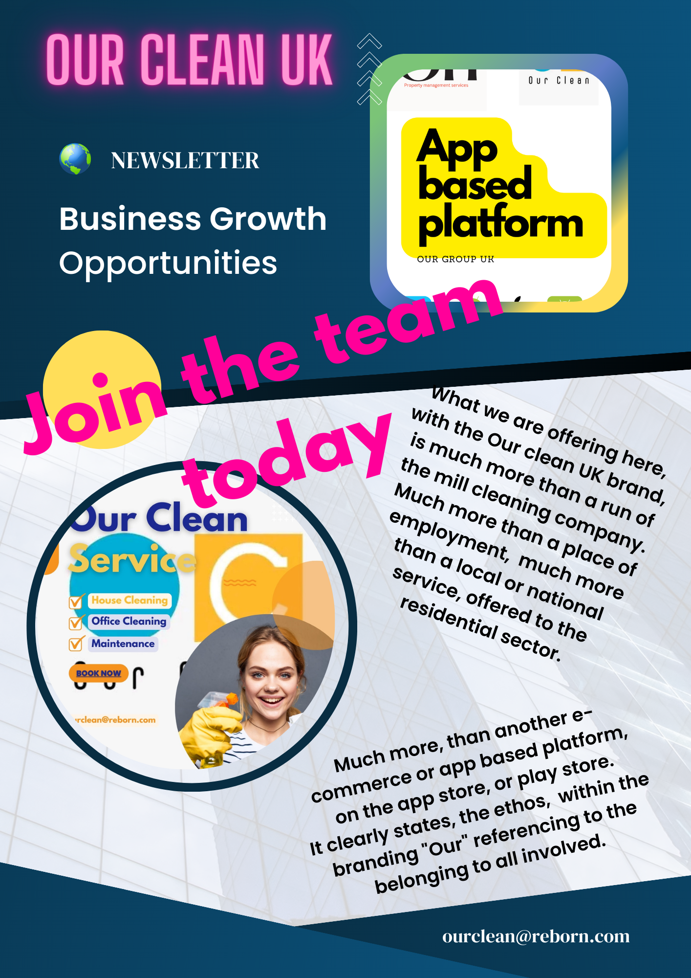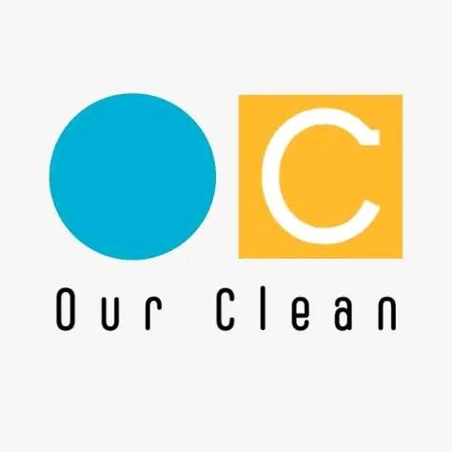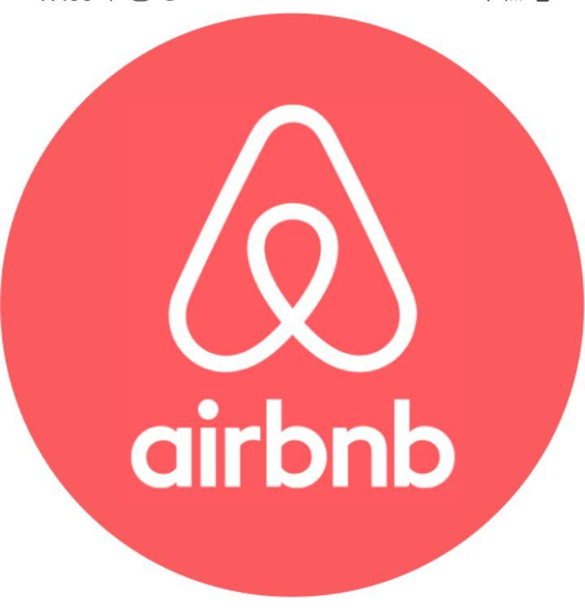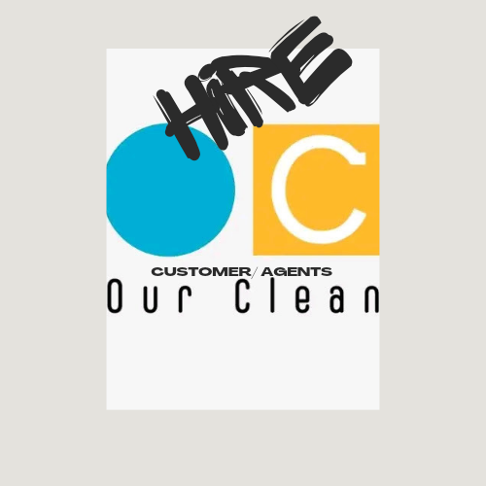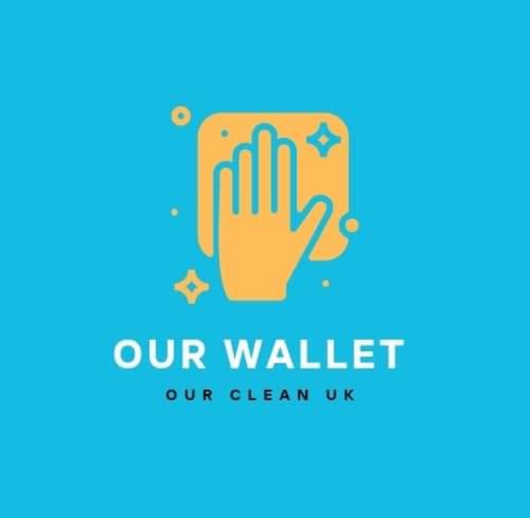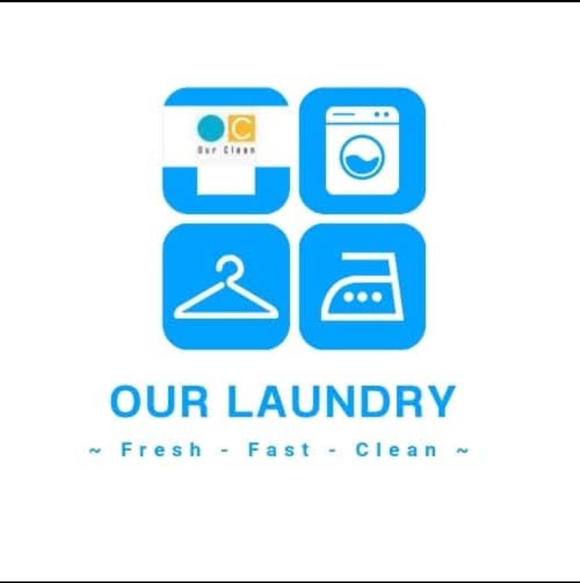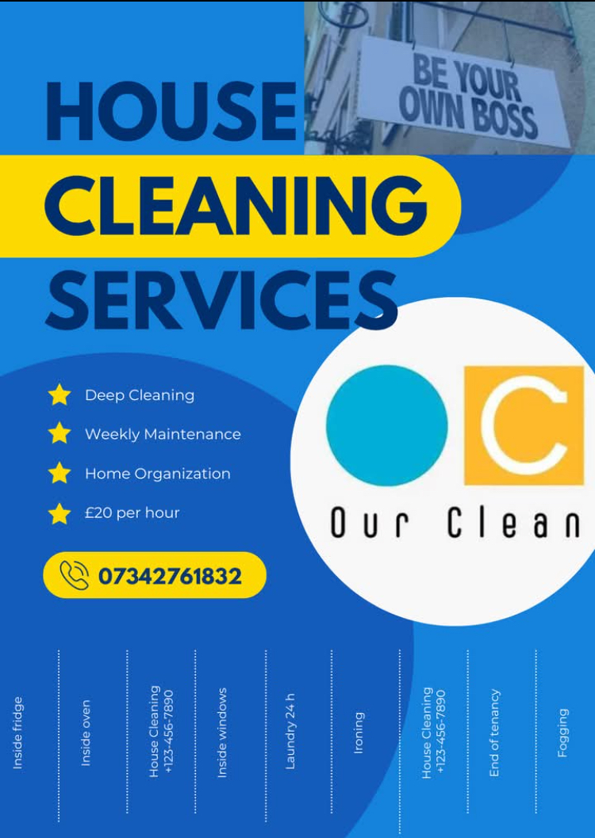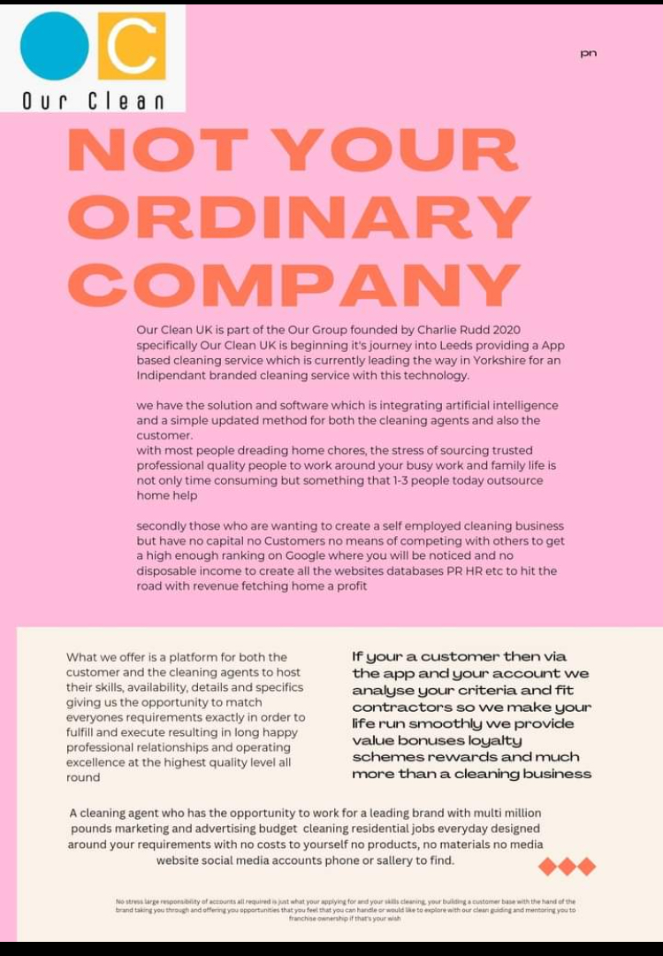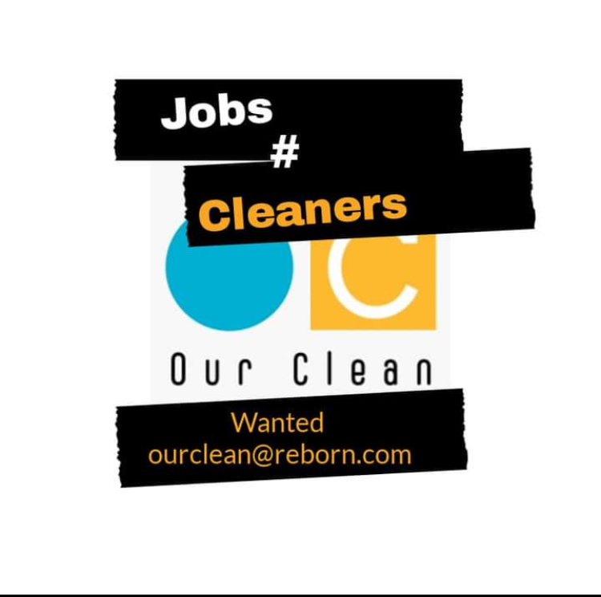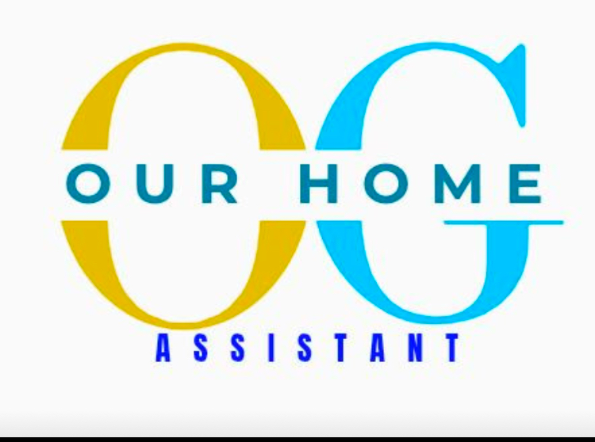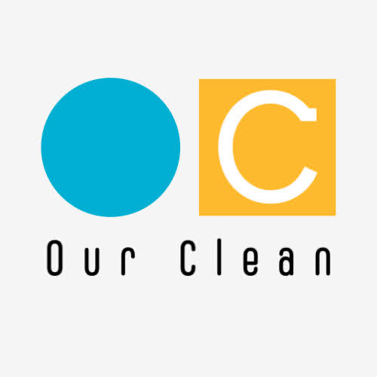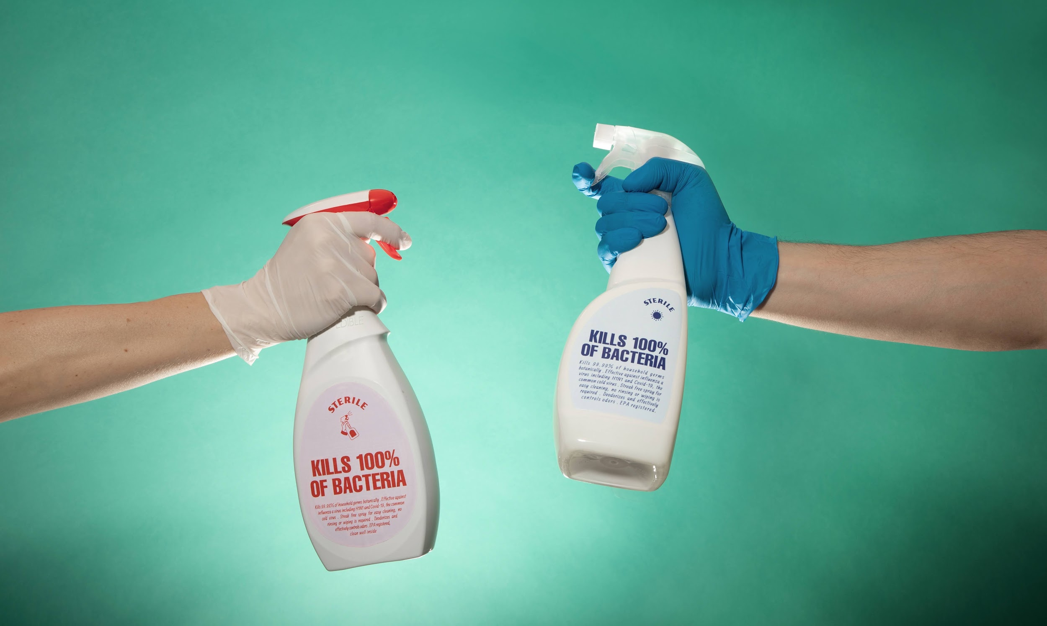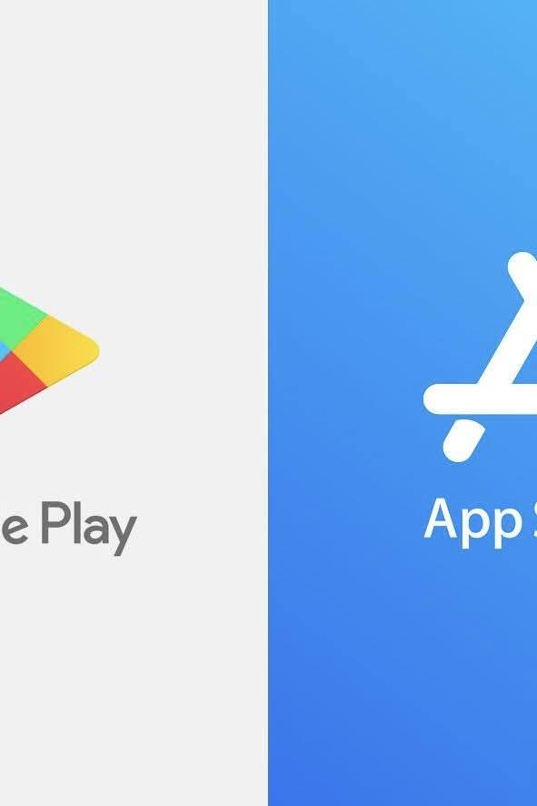

By joining **Our Clean**individuals can leverage a trusted brand to build their own cleaning business, ensuring consistency and reliability in service delivery. We provide:

1. **Zero-Cost Entry**: No initial investment required to start your business.

2. **Brand Trust**: Operate under a recognized and reputable brand, enhancing credibility with customers.

3. **Quality Assurance**: Access to standardized training and resources that ensure high-quality service, regardless of individual cleaning styles.

4. **Supportive Community**: Join a network of like-minded individuals, sharing best practices and strategies for success.

5. **Sustainable Growth**: Build a long-term cleaning diary that fosters customer loyalty and repeat business, supported by our proven methods.

By combining personal ambition with a collaborative framework, **Our Clean** not only enhances the cleaning service experience but also creates pathways for individuals to thrive in the industry.

---

Creating mass recruitment drive across city's over the UK

Giving individuals the opportunity for creating their own SMEs independent cleaning businesses, with the quality and familiarity of a trusted brand and at no costs to themselves, with the vision and possibilities of owning their own franchise

With no necessity for experience and qualifications as all training will be provided and qualifications available funded by the brand if wish so

No need to have to deal with any more or less than the job spec all within the interface of the API app workmate with safe GPS tracking.

Uniform and cleaning products and equipment provided and sent straight to the job so no heavy transportation of equipment needed between jobs.

Offering those with money difficulties advanced salary and signpost for debt advice and consolidation, also the opportunity to create a private pension as an independent sme, managed by an arm of the group.

All jobs, offers, custom base pipeline of your custom base pipeline management and facilities to manage and see your monthly or annual account, timesheets hours diary add-ons as required at additional costs. A estimated system allows you to enter your account to see how you could buy a franchise with a guide and milestones to achieve to work towards this if wanted and tasks, credit building with investment signposts to assist your journey in achieving this goal.

Ongoing training and coaching the Our Clean guidelines and maintenance of excellence and quality

Customer app interface designing your home domestic chores

Creating a account and

Franchise opportunities
What’s the most important thing that being a franchisee will help you to achieve? Is it:
Autonomy and a sense of independence?
Financial freedom and security for you and your family?
Making a difference in real people’s lives?
Becoming an integral part of an industry you love?
Being part of something bigger than yourself?

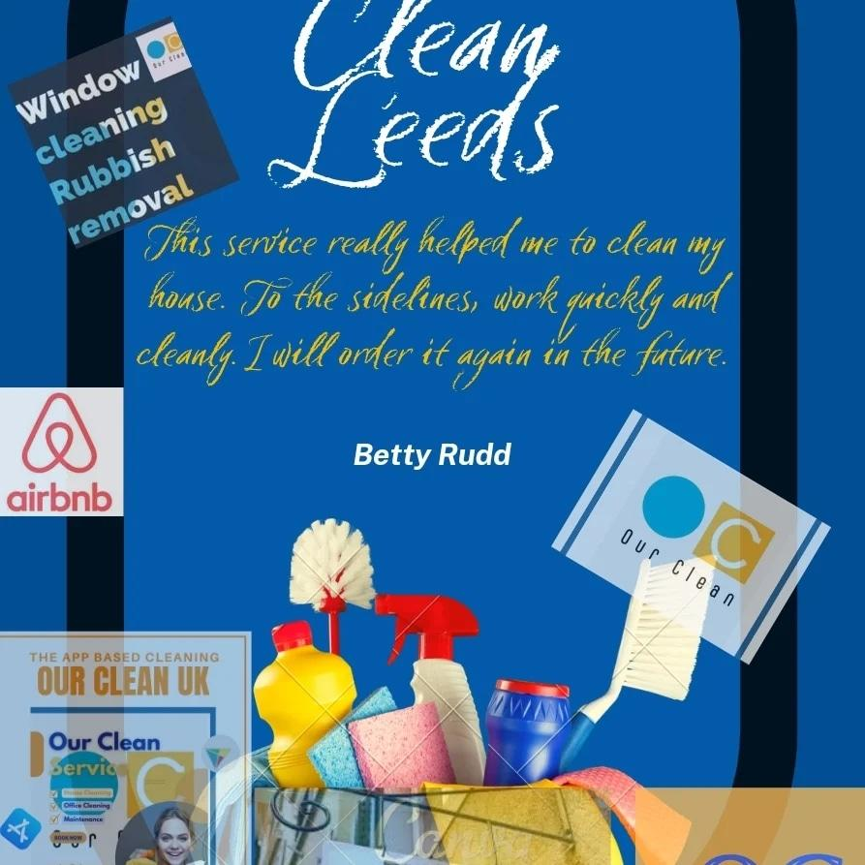

Franchise options with our clean

With an industry that every home workplace, care home school and university require in fact and there's not many industries that doesn't require cleaning.
You have wanted to start your own cleaning business for not being able to find the funds being able to do the marketing and advertising purchase equipment recruitment so on then maybe a franchise with our clean is for you.
The latest technology application based cleaning service it's just what you as the customer or user client require.
Having the power of a brand with buying power marketing campaigns and exciting merchandise already complete for you make things a lot more simple.
We offer flexible hours, flexible locations and huge opportunities of growth within our clean and our group brand.

Why franchising is a great opportunity is because it gives people the opportunity to start and manage their own independent business with the power of a national brand this means you already have a custom base, you have national marketing and advertising campaigns and recruitment in HR becomes easier with the brand behind you.



OUr Clean app
The modern way to book a cleaner or two to recruit cleaning staff.
Simply download the app from the play store or app store enter your postcode and fill the criteria in.
Enter the details and specifics for your clean. This will generated an instant quote, our nearest geographical cleaner will accept the job and arrange with you the customer and them the contractor the details and timetable for the clean. We aim for each cleaner to fill their diary with 2 cleans a day and having the same custom base week in week out.
The simple modern technology of today enables us to organise, keep updated remotely know how and what's happening with the domestic chores that our personal cleaning agent is doing.
Sharing a interactive message service, a simple safe method for booking, invoice and payment and reviews, this latest technology is the first of its quality from the Our Group cleaning division in Leeds and growing across the UK.
With regards to the contractor side of the app, this acts as a workmate, with bookongs, timesheet, payslip, a inventory form for restocking cleaning products for the next clean which is automatically ordered via Amazon and delivered to the address the next day.
Information between customer and contractor with vacant homes to clean will instruct contractors to a key box to gain entry
The contractor app has a GPS and GSM facility on the app, this is to ensure security is paramount and to prevent contractors intercepting customers behind our back, showing the contractor is in breach of contract if they are shown at a customers address outside of contract.



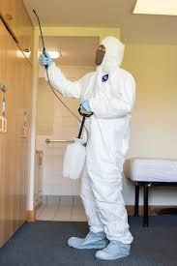

How to find investment for a franchise with Our Group UK?

Before you start searching for franchise finance, you first need to understand the total investment required, including all costs associated with the set-up of the business and the amount required for working capital, fees, VAT, etc.

In order to identify this, you need to prepare a detailed business plan with a full set of financial projections. You can then be clear how much of the total you can contribute and how much you will need to borrow.



Projections and forecast
The profit and loss projections will show the trading activity for the business, sales, costs and how much profit you expect to make. The cash flow forecast will set out the incoming investment from you and any finance, the set-up costs going out, the money coming in and out through the trading activity and VAT.

In simple terms, it’s a forecast of what your bank account will look like at the end of each month.

As it’s part of an application for finance, the business plan needs to include all the information required by the person who’s evaluating your proposal on behalf of the lender.

It should start with an executive summary, which will give a concise overview of the business opportunity and funding requirement. It needs to identify who the owners of the business will be and provide their personal information, including CVs.

You also need to include details of their personal assets (house, investments and savings) and liabilities (mortgages, loans, credit cards, etc).

The lender will want to see that your overall family income is sufficient to cover your overall family/household expenditure, taking into account the money you will earn from your new franchise.

The business plan should include information about the franchisor, the business model, how the franchisor will train and support you and how the products or services will be marketed. It should also set out your business objectives.

Credit score
Keeping your personal credit score in good shape is important. If you’ve not checked it recently, it makes sense to do this and deal promptly with any adverse issues.
It’s also likely that you will be required to provide your bank statements to evidence the fact you operate your bank accounts well and within any agreed borrowing limits.

If you follow these guidelines, you are likely to be able to successfully raise the capital you need Charles Rudd CEO

Fast track your revenue using local and national marketing techniques...

We will help you to grow a strong cleaning portfolio using Best Practices...

Our fully optimized website attracts, educates and converts customers

Creation of your own dedicated webpage for local, personalized content.

Full access to Direct Mailers, Brochures and Email Templates.

Your own dedicated Facebook Page for local news and property availability.

and much more…

For further information contact Our Clean UK Leeds
OUrclean@contractor.net
Regards

CEO Charles James Rudd
CJrudd.

The home domestic cleaning industry is a multi-billion pound industry and growing up to 15% a year.

1 in 3 households now pays for domestic help.

There is a huge demand for local services.

Are you serious about wanting your own online business? Leverage other people’s time to earn your own income.

Unrestricted income as you expand your business. The cleaners do the work and you take a percentage.

Most people fail by becoming their business. You will learn how to manage the company - not be the company.

The truth is, if you know how to market other people’s time properly the potential for you to make money is endless.

You will discover how to source 100’s of potential contractors.

We will create your online business FOR YOU...

You’ll find out how to get sales bookings passively online 24/7...

We will show you how to do EVERYTHING

Skip 18 months of research, learning and costly mistakes and start earning from month one.

You’ll have ongoing support via our dedicated WhatsApp group with Charles to assist you in any questions you may have along the way.

Open to hearing more?

Click below to learn EXACTLY how to begin!

Local Advertising
At every stage of your business journey, you will be supported by a team of experts who have years of combined experience in all of the key areas required for business success, such as fitness, sales, marketing, operations and technology.

Our Group
Franchise agreement

INTRODUCTION

Our Group is a group of independent businesses in a variety of industries.
Giving all income based people the chance to earn, develop and manage their own business as an independent concern with the backing and power of a brand.

Cleaning, a gold and antique buying and selling service, an artificial grass design and installers and an advertising business are just some of the industries that currently we have in operation and opportunities for franchise agreements.

With our group brands marketing and advertising large buying power it makes it possible for small individual businesses to use national marketing mixes and campaigns which get the brand awareness necessary in this day of age.

HYPOTHESIS

To Join the group you first need to have a consultation with our agents and let's show you how we can show you our philosophy and way we operate and what ROI we can offer you
MATERIALS
- We as a brand provide most of the materials required in the different companies we host, some the customer will provide such as cleaning products.

- We provide marketing merchandise and literature required to PR the businesses.

Our Clean

Recruitment

Job Spec

We have designed opportunities of employment which have been thought out with flexibility in mind.

How hours, choosing your location to work and essentially operating your own diary, without any costs to yourself.
Many people are attempting to start their own businesses, building their own customers and contracts.

With start up funds, branding, marketing, advertising and recruitment we all know this is not a method which is affordable before any revenue has been accumulated.
What OUR Clean offers is the opportunity to choose your Hours and location and via an application based method of operating, we will provide a uniform customer base and pay you per hour depending on your experience,qualifications and availability.
All you require is liability insurance and to be responsible for your own HMRC and National Insurance contributions.
Email your enquiry and upload your CV and references, complete the application process and start work there after.

Implementation

Procedure
We are looking to recruit contractors throughout West Yorkshire.
North
East
West
South
Central
Contractors of all able ages, creeds, race and colour.
From a minimum experience of 6 months and Level 2 qualified or not, as training will be provided, by the group.

We want driven professionals whom have the ability to manage their own working diary, with appointments generated by the group.
A desire to learn and operate as an independent, yet work and be part of a national group in the UK.

The cleaning division will expect you to work hours which, will suit you and us, hard work, is not for the faint hearted, within the Rogan Cleaning group.

Expected between 4-12 hours per day will be the usual daily work.
We run domestic, commercial and industrial cleans and we have 30 contractors providing a leading service of up too 30 cleans per day, across West Yorkshire.

Our whole business from the customers through to contractors is operated with the latest technology of Mobil apps, each contractor is required to have their own smartphone and ability to operate it.
Job specifics will be matched with your location and sent across to you, we aim that your jobs will match you with customers that ensures that you and the customers are happy to permanently carry out the contracts for the foreseeable relationship and duration of contract.

The Our Group has a strategic, reliable, professional methodology of working and this is outlined in the contract and must be adhered to as stated.

Depending on your experience and qualifications and your given age we pay contractors between £9:60- £14:05 per hour.

Differentiated Instruction

The process is simple. We ask you to fill the criteria in the application process and please give as much detail as possible to ensure that we can match your specifications with each role correctly.

Personal Details
Experience
Qualifications
Work permit in the UK
Medical and health requirements
Criminal record in the last 5 years
Driving license
Can you work in all environments & with others?

Materials & Resources
All cleaning products will be provided, you will be responsible to ensure you keep the inventory of materials on each clean updated, ordered and to take delivery at each clean of new products.

You will be provided with a uniform and ID badge which must both be worn at all times unless Hazardous and if you lose or misplace these you will be required to pay for the replacements.

It is your requirement as an independent contractor to hold current public liability insurance and be responsible for paying your own HMRC and National Insurance contributions.

You will be shown and told that as part of your agreement, that your app is your mandatory part of your role and must be used as stated on every clean and it’s your responsibility with regards to your time sheet built into the app.

Assessment
You will be assessed with reference to your attendance, customer satisfaction and job satisfaction.

This will consist of appraisals, which will look at monthly targets, bonuses and opportunities within the group for you, for career and education requirements.

What to do next?
ourclean@reborn.com

email your application enquiries to the email address above and we will take your application through the process and start your journey into the cleaning industry

Join
ourclean@reborn.com

Disclaimer

DISCLAIMER
The Our Group make every effort to ensure that we accurately represent the franchise business opportunity and its potential for producing income for business owners who apply themselves to operating the business properly. Examples of income earned and other results are not necessarily average or typical nor intended as representations of your potential earnings. As with any business opportunity or training, each individual’s results may vary widely. Each individual’s results depend on his or her background, dedication, desire, motivation and particular applications. Significant financial risk is possible with any business venture or opportunity if you don’t do your own due diligence and get suitable professional advice. No guarantees of specific results are expressly made or implied.

